Ambient Light Sensor System
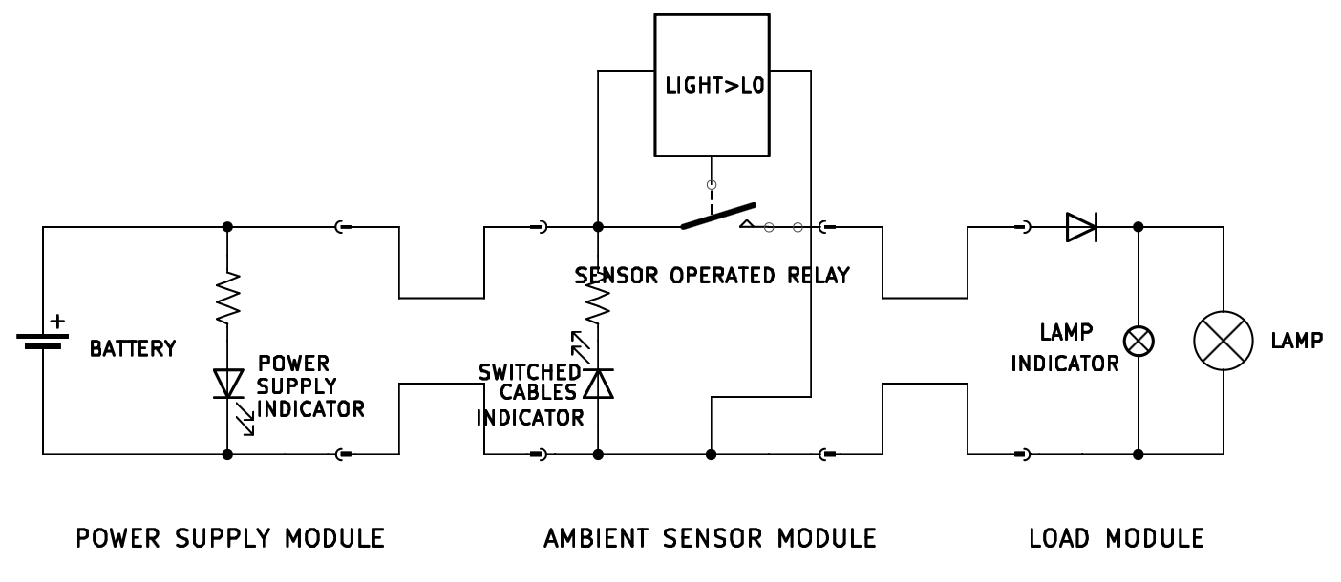

The system has the overall function of operating a load (lightbulb).

The system is composed of three modules connected in series: a power supply module, a control module, a load module.
Each module is made of an electrical circuit encased in a plastic box.
The modules are connected by cables: two cables come out of one face of the power supply box and of the load box, four cables come out of two opposite faces of the control module box (two cables per face).
The cable terminates with fast-connection terminals that can be attached and detached together, allowing for connecting and disconnecting the modules together, and switching the cables polarity of two connected modules.
The circuit inside each module can be inspected through a dedicated panel.

The three plastic boxes are stacked on top of each other: first, at the bottom, the power supply module, then the control module, and finally the load module.

Inside the power supply module box, there is a battery case for a 12V lithium battery. On the top face there is a green LED. The LED is in series with a resistor, and the LED and the resistor are in parallel to the source, and the LED is oriented so that it will turn on when the 12V source is active and connected. Of the cables that exit the module, one is connected to the 12V input positive port, the other to the negative port.

The four cables coming out of the control box constitute two connected pairs (so during operations one cable per face will have 12V, the other 0V). One such pair can be opened by a relay. The relay is controlled by an ambient light sensor: if the ambient light is lower than a certain threshold, the relay contacts will be closed and the 12V will be supplied to the output ports, if the ambient light is higher than a certain threshold the relay will be open, and no voltage will be present at the output ports. Two adjustable potentiometers are used to regulate the switching delay and the sensitivity of the sensor.

The two cables coming out of the load module are simply connected to the load ports. The lightbulb is mounted on one of the lateral faces of the plastic box. In parallel to the lightbulb there is a smaller lightbulb, that is positioned inside the box, and can be seen only by either accessing the box or by opening a small peephole located on one of the box faces. Both lightbulbs are not polarized by themselves, however there is a diode located on the 12V line, before both lightbulbs, such that it will allow current to flow only if the 12V and 0V lines are actually energized with 12V and 0V respectively (it will block current if the polarity is switched).

